Introduction to Linear Algebra
Linear Algebra is the branch of mathematics that deals with vectors, matrices, and operations on them. It forms the backbone of machine learning, computer graphics, optimization, and data science.

1. Vectors
A vector is an ordered list of numbers.

You can think of vectors as points in space or as directions.
Key operations
- Addition: add element-wise
- Scalar multiplication: multiply each element by a number

2. Matrices
A matrix is a rectangular array of numbers arranged in rows and columns.
Represent:
- Linear transformations
- Datasets (rows = samples)
- Neural network weights

3. Matrix Multiplication
Matrix multiplication is not element-wise.
Definition:
Intuition:
Each row of A interacts with each column of B.

4. Transpose of a Matrix
The transpose of matrix (A) is obtained by flipping rows and columns.

5. Special Matrices

a) Identity Matrix (I)
Diagonal elements = 1, others = 0
[
AI = IA = A
]

b) Diagonal Matrix
Only diagonal entries can be non-zero.

c) Symmetric Matrix
[
A = A^T
]

d) Orthogonal Matrix
An orthogonal matrix is a square matrix whose transpose equals its inverse. This means multiplying the matrix by its transpose results in an identity matrix. Its rows and columns are mutually perpendicular.
Geometrically, orthogonal matrices represent transformations that preserve distances and angles, such as rotations and reflections.
Key Mathematical Conditions

Inverse matrix calculations:
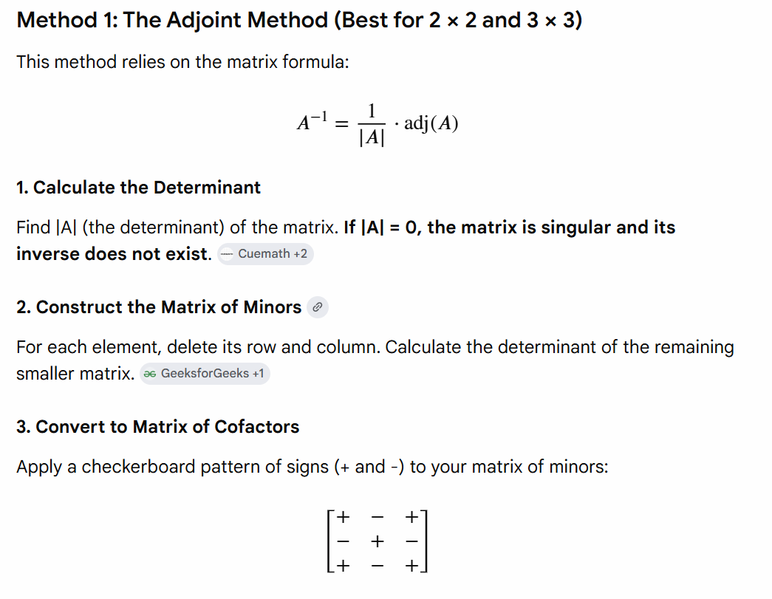
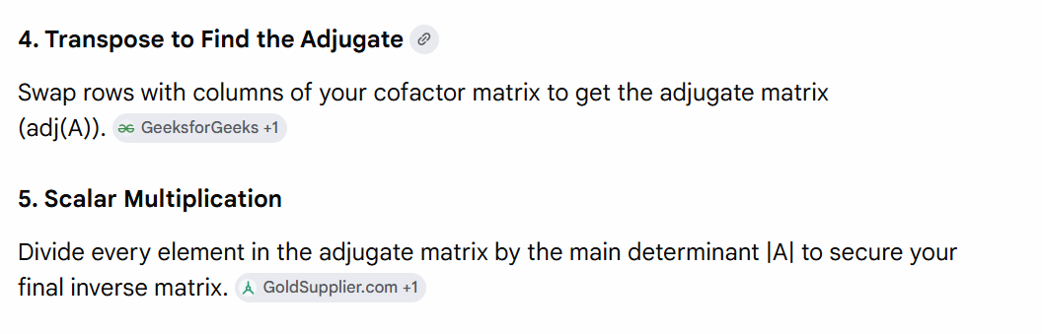

For a square matrix A, the condition to be orthogonal is:
$$A^{T}=A^{-1}$$
This fundamentally means that:
A A^T = A^T A = I
(where \(A^{T}\) is the transpose of A and I is the identity matrix)
Core Properties
- Orthonormal Vectors: All rows and columns are "unit vectors" (magnitude of 1) and are mutually perpendicular (their dot product is 0).
- Determinant: The determinant of an orthogonal matrix is always +1 or -1.
- Norm Preservation: Multiplying a vector by an orthogonal matrix does not change its length.
- Eigenvalues: All eigenvalues of an orthogonal matrix are complex numbers with an absolute value of 1
A Practical Example
Consider the 2 × 2 standard rotation matrix, which rotates a vector by an angle θ: [
\(A = \begin{bmatrix} \cos\theta & -\sin\theta \\ \sin\theta & \cos\theta \end{bmatrix}\) [1]
If you take the dot product of the first column \(\left[\begin{matrix}\cos \theta \\ \sin \theta \end{matrix}\right]\) and the second column \(\left[\begin{matrix}-\sin \theta \\ \cos \theta \end{matrix}\right]\), it yields 0. The magnitude of both vectors is 1. Therefore, it forms an orthogonal matrix. [1]
Important for rotations, PCA, SVD.

6. Properties of Matrix Operations
- (A + B = B + A)
- (AB \neq BA) (matrix multiplication is not commutative)
- ((AB)^T = B^T A^T)
- Scalar multiplication distributes:
[
c(A + B) = cA + cB
]

7. Determinant of a Matrix
For a 2×2 matrix:
[
\det(A) = ad - bc
]
Interpretations:
- Area/volume scaling factor of transformation
- If det = 0 → matrix is singular (non-invertible)
- If det ≠ 0 → inverse exists

8. Cosine Similarity
Measures similarity between two vectors using the angle between them.
Used in:
- NLP embeddings
- Recommendation systems
- Clustering

9. Eigenvalues and Eigenvectors
For matrix (A):
[
A v = \lambda v
]
Where:
- (v) is an eigenvector
- (\lambda) is its eigenvalue
Meaning:
Applying (A) to (v) only stretches or shrinks it—no change in direction.
Used in:
- PCA (principal components = eigenvectors)
- Graph analysis
- Stability analysis

10. Tensors
A tensor is a generalized matrix.
Object | Order | Example
Scalar | 0 | 5
Vector | 1 | [1,2,3]
Matrix | 2 | 2D grid
Tensor | 3+ | Image (H×W×3), NN parameters
Machine learning frameworks (TensorFlow, PyTorch) use tensors as fundamental data structures.

